European Lawyers in Lesvos - Application form for volunteer lawyers
Basic information:
Surname _________________________ Name _______________________________
Gender __________________________
Address _________________________________________________________________
Mobile phone number _____________________________________________
Email-address __________________________________________________
Nationality ______________________________________________________
Date of birth _____________________

Professional information:

Member of ______________________ Bar/Law Society since ____________
Experience in Asylum Law practice (in years) _____________________________________
Experience in Asylum Law practice (number of cases) ______________________________
Other relevant experience in dealing with asylum affairs _____________________________
Language Competences:
Languages | Level
 | Native | Fluent | Intermediate | Beginner
English
Arabic
Greek
Farsi
French
Other
___________

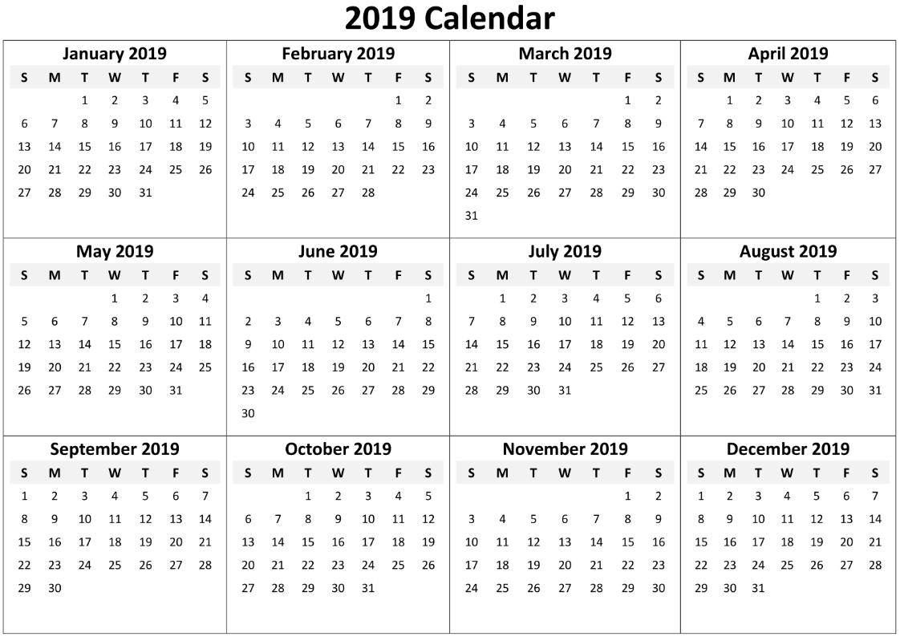

Preferred period of volunteer activity (minimum. 3 consecutive weeks) ________________________
Please attach the following documents:
- A copy of certificate of admission to/membership of the bar
- CV
- Please describe in one page why you are suitable for this project (in English)

